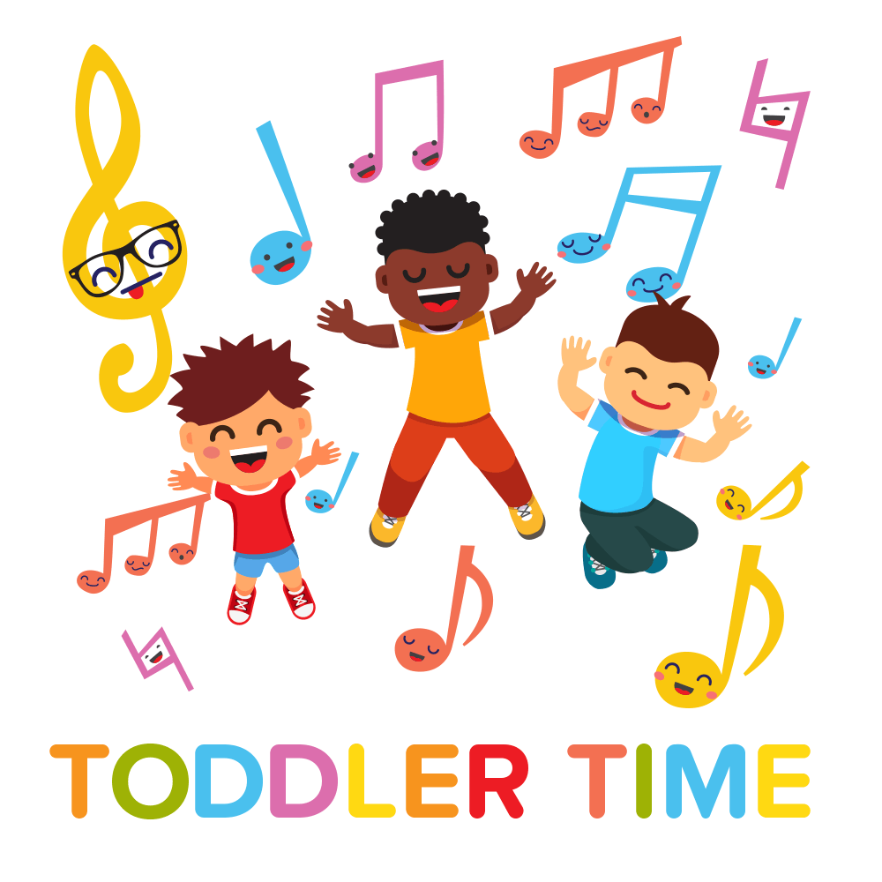
10:30 a.m. in the library
Thursday: Nov. 15th Birth to 4
*Tuesday*: Nov. 20th all ages
Thursday: Nov.29th Birth to 4
Thursday: Dec. 13th Birth to 4
Thursday: Dec. 20th all ages
Thursday: Dec. 27th all ages

